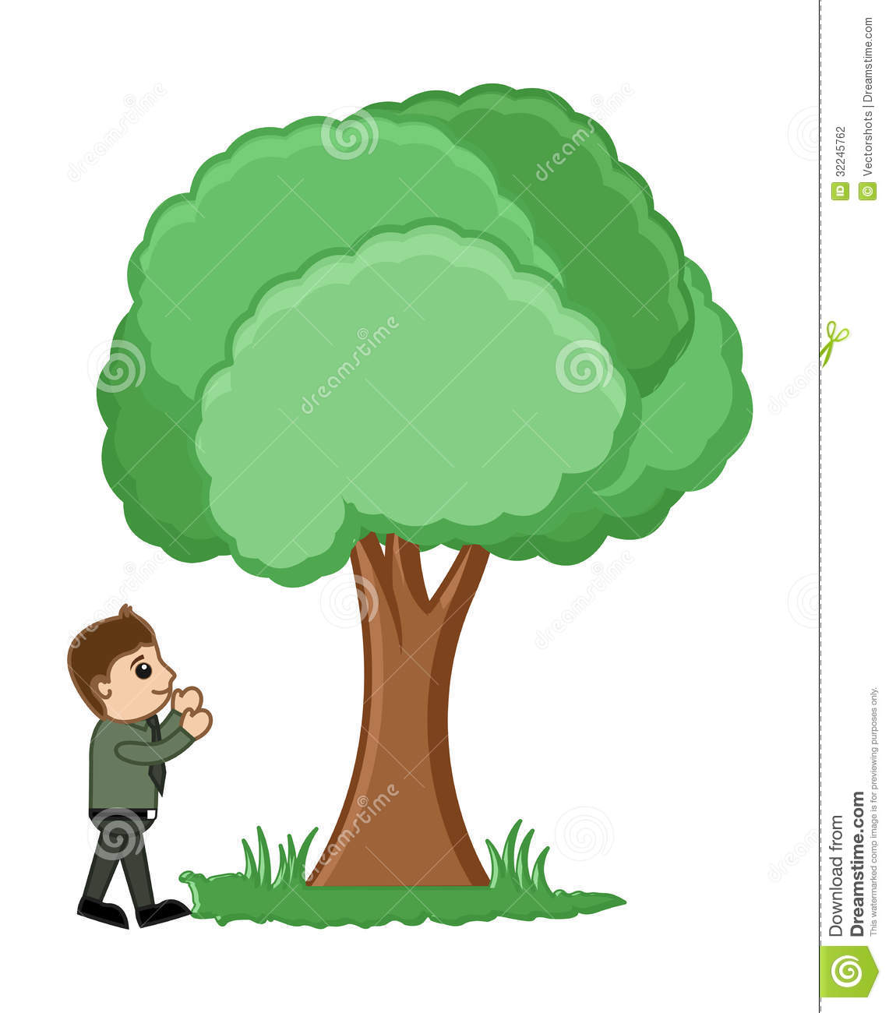

MAN AND A TREE

-Payal Mangla, BVCOE

MAN - Hello tree! How are you? Tell me something new?

TREE - I am good, and as always, preparing food and O₂.

MAN - Why do you grow so tall, tree?

TREE - I love these heights at which I am.

They make me feel free.

The warmth, the glow, lightness and coolness of nature is with me.

This is what keeps me healthy and happy.

Way up here, I see the marvelous turquoise sky.

My little friends who fly, and others who go by.

MAN - Hey tree, you remain so quite, do you have friends?

TREE - The cool wind, glistening clear water, teeming soil, the ground,

Birds, flies, eagles, and so many other animals that keep coming around

They nest with me, they rest with me.

They take care of me, even when I don’t make a sound.

MAN - What do you use for food, to help you grow and grow?

TREE - I live on a diet of Nature’s best from my roots deep down below.

I never go hungry, I rest and rest and wait for rain and snow.

MAN - Hey tree, look at your colour! Do you think you look good in brown and

Green?

TREE - Beauty lies in the eyes through which I am seen.

I’m very happy and love what nature has given me.

MAN - You lose your leaves in autumn; don’t you feel a lot of pain?

TREE - My falling leaves rake a carpet which saves the ground from frost, that

For me is rather a gain.

MAN - We cut you for pulp, fuel, timber,

Wood for houses and furniture.

Is there a message you want to send?

TREE - I just want so say, we trees are your best friends.

We love to help you when you want a hand.

But we expect you to help five others to flourish and stand.

MAN - Hey tree, what do you think standing like this for the whole day?

TREE - Those who I work hard for don’t make me disappear, this is what I pray.

